**ANNA-MITRA**

**A PROJECT REPORT  
For  
Mini Project (KCA353)  
Session (2023-24)  
Submitted by**

**Sumit SIngh Rawat**

**2300290140188  
Pratham Dhingra**

**2300290140126**

**Submitted in partial fulfilment of the  
Requirements for the Degree of**

**MASTER OF COMPUTER APPLICATION**

**Under the Supervision of  
Mr. Ritesh Kumar Gupta  
Associate Professor**



**Submitted to**

**DEPARTMENT OF COMPUTER APPLICATIONS**

**KIET Group of Institutions, Ghaziabad  
Uttar Pradesh-201206  
(March-2024)**

**DECLARATION**

We hereby declare that the work presented in this report entitled **“Anna-Mitra"**, was carried out by us. We have not submitted the matter embodied in this report for the award of any other degree or diploma of any other University or Institute.

We have given due credit to the original authors/sources for all the words, ideas, diagrams, graphics, computer programs, experiments, results, that are not my original contribution. We have used quotation marks to identify verbatim sentences and given credit to the original authors/sources.

We affirm that no portion of my work is plagiarized, and the experiments and results reported in the report are not manipulated. In the event of a complaint of plagiarism and the manipulation of the experiments and results, We shall be fully responsible and answerable.

**Sumit Rawat** (2300290140188)  
 **Pratham Dhingra** (2300290140126)

**ACKNOWLEDGEMENT**

At the outset, we would like to thank our guide and advisor**, Mr. Ritesh Kumar Gupta Associate Professor,** for giving us an opportunity to work on this challenging topic and providing us ample and valuable guidance throughout the Project.

Without his encouragement and constant guidance, we would not have able to finish this project. He has been always a source of inspiration and motivator for innovative ideas during the entire span of this work.

We are grateful **Dr. Arun Tripathi Sir, Professor and Head, Department of Computer Applications, KIET Group of Institutions, Ghaziabad** for providing all the necessary resources

to carry out this Project work.

We will be failing in our duty if we don’t acknowledge the people behind this work to give us moral and psychological support. Our special thanks to our parents for their endless care and constant support.

**Sumit Rawat** (2300290140188) **Pratham Dhingra (**2300290140126)

**Abstract**

Food is one of the basic necessities of humans, and it stands first among all basic needs – food, shelter, and clothing. It is important as it nourishes the human body- sustaining the very existences of humans. However, with the rising population and development of this country, food wastage has risen to a new high. There are many people who wish to donate food to the needy but are unaware of how exactly they can execute that. Our application revolves around helping the needy by connecting NGOs and common people. The donors shall be able to see a plurality of options by which they can donate. The NGOs will get the details of the persons wishing to donate via our application and thus a network is established between donors, people who aid the donors in donating (NGOs) and the actual needy people to whom the donated item is sent. Our application aims to bring about transparency, clarity and swiftness in the process of donation thus aiming to mitigate prevailing issues in whatever zone it is possible for us to do so.

**INDEX**

| **Sr. No.** | **Content** | | | | | |  | |
| --- | --- | --- | --- | --- | --- | --- | --- | --- |
| **1** | **Chapter 1: Introduction** | | | | | |  | |
|  | **1.1** | | **Problem Summary** | | | |  | |
|  | **1.2** | | **Shodh Yatra** | | | |  | |
|  | **1.3** | | **Aim and Objective of the project** | | | |  | |
|  | **1.4** | | **Problem Specification** | | | |  | |
|  | **1.5** | | **Work Plan** | | | |  | |
| **2** | **Chapter 2: Requirement Analysis** | | | | | |  | |
|  | **2.1** | | **Functional Requirement** | | | |  |
|  | **2.2** | | **System Requirement** | | | |  |
|  | **2.3** | | **Hardware Requirement** | | | |  |
|  | **2.4** | | **Software Requirement** | | | |  |
|  | **2.5** | | **Feasibility Study** | | | |  |
|  | **2.6** | | **System Limitation** | | | |  |
|  |  | | **2.6.1** | | **Technical Feasibility** | |  |
|  |  | | **2.6.2** | | **Operational Feasibility** | |  |
|  |  | | **2.6.3** | | **Economic Feasibility** | |  |
| **3** | **Chapter 3: SYSTEM DESIGN** | | | | | |  |
|  | **3.1** | | **System Architecture** | | | |  |
|  | **3.2** | | **System Diagrams** | | | |  |
|  |  | | **3.2.1** | | **Class Diagram** | |  |
|  |  | | **3.2.2** | | **Use Case** | |  |
|  |  | | **3.2.3** | | **Activity diagram** | |  |
|  |  | |  | | **3.2.3.1** | **For Registration** |  |
|  |  | |  | | **3.2.3.2** | **For Login** |  |
|  |  | |  | | **3.2.3.3** | **For NGO Management** |  |
|  |  | |  | | **3.2.3.4** | **For Donor** |  |
|  |  | |  | | **3.2.3.5** | **For Volunteer** |  |
|  |  | | **3.2.4** | | **Sequence Diagram** | |  |
|  |  | |  | | **3.2.4.1** | **For NGO Management** |  |
|  |  | |  | | **3.2.4.2** | **For Donor** |  |
|  |  | |  | | **3.2.4.3** | **For Volunteer** |  |
|  | **3.3** | | **Database Design** | | | |  |
|  |  | | **3.3.1** | | **E-R Diagram** | |  |
|  |  | | **3.3.2** | | **Data Dictionary** | |  |
|  |  | |  | | **3.3.2.1** | **Donor table** |  |
|  |  | |  | | **3.3.2.2** | **Volunteer table** |  |
|  |  | |  | | **3.3.2.3** | **NGO management** |  |
|  |  | |  | | **3.3.2.4** | **Registration details table** |  |
|  |  | |  | | **3.3.2.5** | **Registered User** |  |
|  |  | |  | | **3.3.2.6** | **Donated Items table** |  |
|  | **3.4** | | **Business model canvas** | | | |  |
| **4.** | **Chapter 4: SYSTEM DESCRIPTION** | | | | | |  |
|  | **4.1** | | **Software Description** | | | |  |
| **5.** | **Chapter 5: SYSTEM IMPLEMENTATION** | | | | | |  |
|  | **5.1** | **System information** | | | | |  |
|  |  | **5.1.1** | | **Coding standards** | | |  |
|  |  | **5.1.2** | | **Total module** | | |  |
|  | **5.2** | **Project** | | | | |  |
| **6.** | **Chapter 6: CONCLUSION AND FUTURE SCOPE** | | | | | |  |
|  | **Reference, Conclusion and Future Scope** | | | | | |  | |
|  | **Appendix A: Canvas** | | | | | |  | |

**List of Figures**

| **Sr. No.** | **Title** | **Page No** |
| --- | --- | --- |
| **Figure 1.1** | **Gantt chart/Timeline chart** |  |
| **Figure 3.1** | **Three tier Architecture** |  |
| **Figure 3.2** | **Class Diagram** |  |
| **Figure 3.3** | **Use Case Diagram** |  |
| **Figure 3.4** | **Activity Diagram for Registration** |  |
| **Figure 3.5** | **Activity Diagram for login** |  |
| **Figure 3.6** | **Activity Diagram for NGO management** |  |
| **Figure 3.7** | **Activity Diagram for Donor** |  |
| **Figure 3.8** | **Activity Diagram for Volunteer** |  |
| **Figure 3.9** | **Sequence Diagram for NGO management** |  |
| **Figure 3.10** | **Sequence Diagram for Donor** |  |
| **Figure 3.11** | **Sequence Diagram for Volunteer** |  |
| **Figure 3.12** | **E-R Diagram** |  |
| **Figure 3.13** | **BMC Canvas** |  |
| **Figure 5.1** | **AEIOU Canvas** |  |
| **Figure 5.2** | **Empathy Canvas** |  |
| **Figure 5.3** | **Ideation Canvas** |  |
| **Figure 5.4** | **Product Development Canvas** |  |

**List of Tables**

| **Sr. No.** | **Title** | **Page No** |
| --- | --- | --- |
| **Table 3.1** | **Donor Table** |  |
| **Table 3.2** | **Volunteer Table** |  |
| **Table 3.3** | **NGO management Table** |  |
| **Table 3.4** | **Registration Details** |  |
| **Table 3.5** | **Registered User** |  |
| **Table 3.6** | **Donated Items Table** |  |

**Chapter: 01**

**INTRODUCTION**

**1.1 Problem Summary**

* In the current working scenario, many NGOs are struggling with some issues mainly communication with their member, heads and volunteer while NGO are donating. One of our members is volunteer of an NGO namely Robin Hood army and main objective of the NGO is to feed the poor people. As volunteer, our member has to visit the restaurants, individual donations and some processed foods. He is facing many problems like communication issues, Missing some places for picking up food, unable to find location for volunteer and much more.
* Hence, we came up with our Android Application, this app is for every NGO available in the particular city and donate things like Clothes, food, stationary items and much more.

**1.2 Shodh Yatra**

* In highly populated countries like India, food wastage is a disturbing issue.
* Food wastage is not only an indication of hunger or pollution, but also of many economic problems.
* Instead of wasting these things we can put them in use by donating them to various organizations such as orphanages, old age homes, etc. The product is an internet-based android application that basically aims at charity through donations.
* The definition of this app **Spread A Smile** was well thought and discussed by us.
* One of our members is volunteer of an NGO namely Robin Hood army and main objective of the NGO is to feed the poor people.
* As volunteer, our member has to visit the restaurants, individual donations and some processed foods.
* He is facing many problems like communication issues, Missing some places for picking up food and much more. Hence, we came up with our Android Application, this app is for every NGO available in the particular city and donate things like Clothes, food and much more.

**1.3 Aim and Objective of the project**

* The objective of our application is to enable a link of communication and interactions among NGOs, donors and the needy.
* The people wishing to donate will be able to see all the options available with them to do the same. The item they wish to donate then shall be collected by a volunteer who is connected to the donors via our application.
* The donated item shall safely reach the intended needy persons after this interaction. In other words, our project has the following objectives:
  + Reduce lack of awareness
  + Enable easy interaction between donors and organizations
  + Make work faster and quicker by digitising it via our app

**1.4 Problem Specification**

* It is crucial for all the NGO volunteers to communicate with each other in order to give proper delivery to the needy people.
* It is also important for the people to know about NGO’s, so that they can donate at their items ease.

**1.5 Work Plan**

* We have completed the requirement gathering and the analysis phase for our app/software. We have also finished preparatory documents.
* We have also performed other activities like study of relevant PSAR and development of various canvases such as AEIOU, Empathy, Ideation and Product development canvas. We also began the designing part of the application.

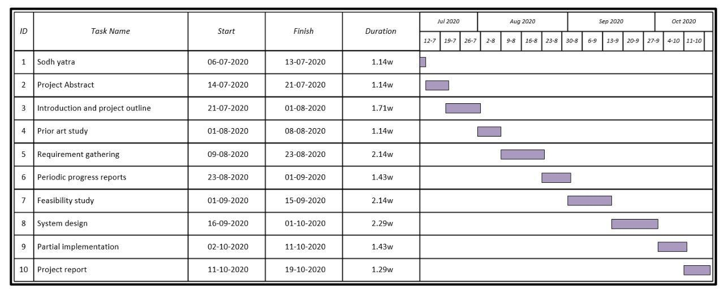

**Chapter : 02**

**REQUIREMENT ANALYSIS**

**2.1 Functional Requirement**

These are the requirements that the end user specifically demands as basic facilities that the system should offer. All these functionalities need to be necessarily incorporated into the system as a part of the contract.

1. For Donor
   1. Donate item (click on donate, then select what item and in which form you wish to donate and have a volunteer pick up your item for you)
   2. Check where the volunteer has reached and the status of your donated item
   3. Search and select NGO as per need
2. For volunteers
   1. Accept requests given by management
   2. Go to the locations and pick up the items that are provided by the donor.

3. For NGO management

* 1. Accept and manage requests by the donors and assign volunteers for the same
  2. Keep track of the performance and whereabouts of the volunteers

1. For admins
   1. Admins shall manage database information and shall do relevant tasks related to the same.

**2.2 Non-functional Requirements**

* These are basically the quality constraints that the system must satisfy according to the project contract. They are also called non-behavioural requirements.
* They basically deal with issues like:

1. Portability
   * Since this is an android application, it shall be available for the majority of android users on their mobile phones.
2. Usability
   * The system needs to be easy to use and understand. Our application will be easy for users to navigate through and they can easily use the functionalities of the app in a smooth manner. Changing of various activities shall allow for easy shifting of tasks.

3. Privacy

* + The application shall take care of not to leak any donor's personal profile information to other users or people. Only information relevant and necessary shall be visible.

4. Performance

* + The app should respond to users in a considerable time window. It should not be too slow or too fast for the users. The application's response time should not hinder the user in his tasks.

5. Scalability

* App should able to adapt itself to the increased user load or more users in order to handle more data as time progresses.

6. Reliability

* + The application should be reliable to perform its tasks. For example, a user should rely that in case he wishes to donate an item, request is sent to the volunteer side otherwise it would be an unreliable app.

**2.3 System Requirement**

System requirements are all of the requirements at the *system level* that describe the functions which the system as a whole should fulfill to satisfy the stakeholder needs and requirements, and are expressed in an appropriate combination of textual statements, views, and non-functional requirements; the latter expressing the levels of safety, security, reliability, etc., that will be necessary.

System requirements play major roles in systems engineering, as they:

* Form the basis of system architecture and design activities.
* Form the basis of system integration and verification activities.
* Act as reference for validation and stakeholder acceptance.
* Provide a means of communication between the various technical staff that interact throughout the project.
  1. **Hardware Requirement**
* Processor: SD or 2.6 GHz+
* Memory: 2GB RAM
* Hard Disk: 100MB free space on a device.
  1. **Software Requirement**
* OS: Android 5.0+
* GPS availability
  1. **Feasibility Study**
     1. **Technical Feasibility**
* Analysis of technical resources available in the organizations concerning the project requirement comes under technical feasibility. The project is an android application that shall be coded in android studio.
* API and lookup technologies are used for tracking purpose. Necessary Tools will be used for statistical analysis of the work done by the volunteers.
* Databases would be made using springboot. The Spring Framework is an application framework and inversion of control container for the Java platform.
  + 1. **Operational Feasibility**
* Users of the system are familiar with the website navigation.
* Simple GUI.
* Data retrieval and data processing will be done by the system.
  + 1. **Operational Feasibility**
* Economic feasibility determines whether there are sufficient benefits in creating to make the cost acceptable or is the cost of the system to high the software used to develop the proposed system are cost efficient.
* Our app will be developed using Android Studio and its database will be springboot, therefore these things will make our app more cost efficient.
  1. **System Limitation**
* One limitation of our app is that it will not work in IOS environment.

**Chapter : 03**

**SYSTEM DESIGN**

**3.1 System Architecture**

The system will be developed using 3-tier architecture:

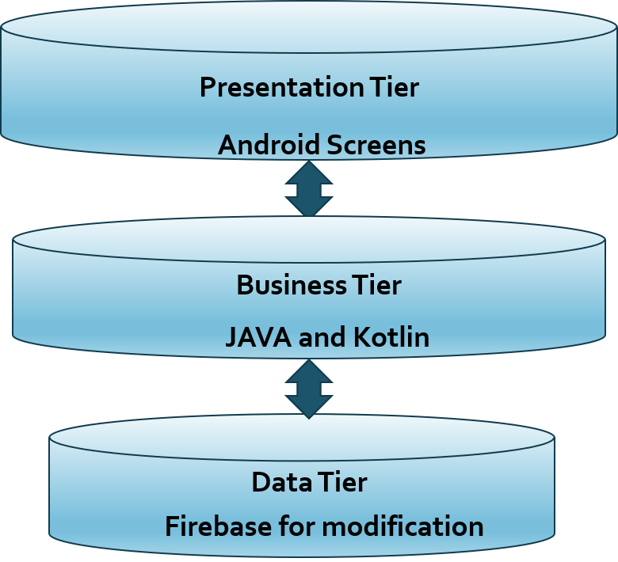

**Fig. 3.1** Three Tier Architecture

1. **Presentation Layer (UI) :**  
   Presentation layer contains pages like .aspx or windows form where data is presented to the user or input is taken from the user.
2. **Business Access Layer (BAL) or Business Logic Layer :**  
   BAL contains business logic, validations or calculations related with the data, if needed.
3. **Data Access Layer (DAL) :**  
   DAL contains methods that help the business layer to connect the data and perform required action, might be returning data or manipulating data (insert, update, delete etc).

We selected 3-tier architecture because the three important modules like the UI, logic and database are independent of each other and are clearly defined. Also modifying any one tier will not affect the other. Along with it we get the following benefits for using 3-tier architecture:

* **Scalability**: Each tier can scale horizontally. For example, you can load-balance the Presentation tier among three servers to satisfy more Web requests without adding servers to the Application and Data tiers.
* **Performance**: Because the Presentation tier can cache requests, network utilization is minimized, and the load is reduced on the Application and Data tiers. If needed, you can load-balance any tier.
* **Availability:** If the Application tier server is down and caching is sufficient, the Presentation tier can process Web requests using the cache.

**3.2 System Diagrams**

**3.2.1 Class Diagram**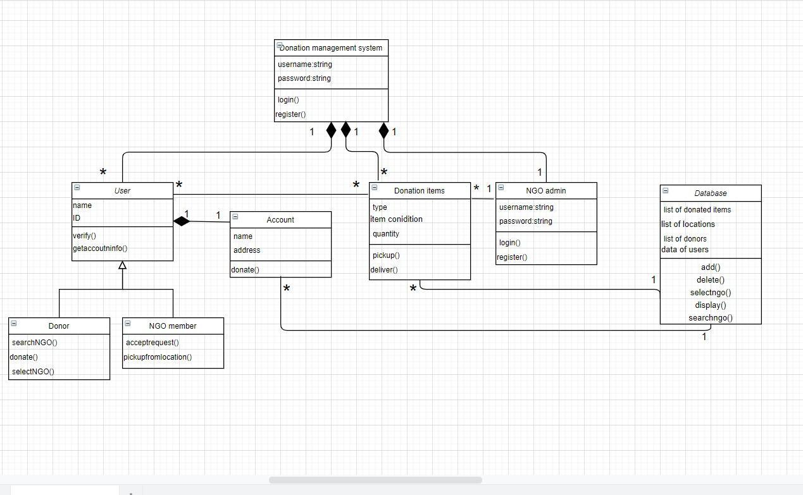

**Fig 3.2** Class Diagram

**3.2.2 Use Case**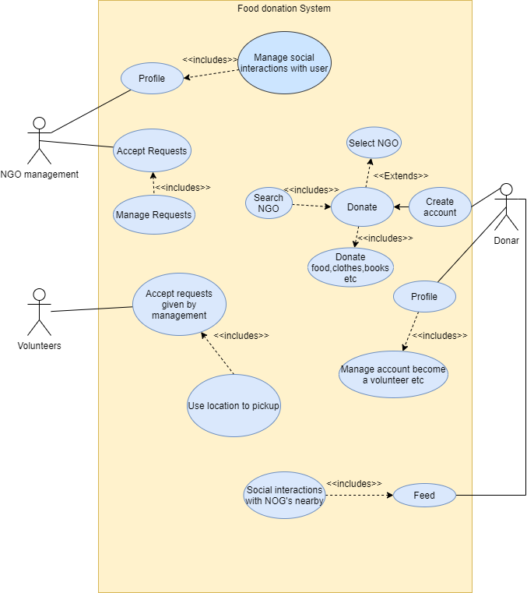

**Fig 3.3** Use Case Diagram

**3.2.3 Activity Diagram**

**3.2.3.1 Activity Diagram for Registration**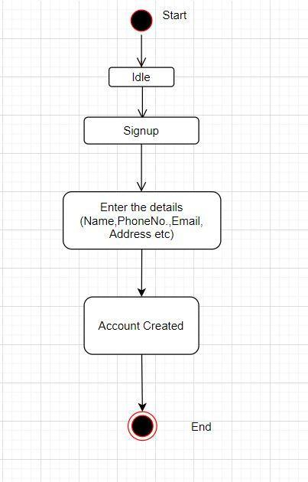

**Fig 3.4** Activity Diagram for Registration

**3.2.3.2 Activity Diagram for Login**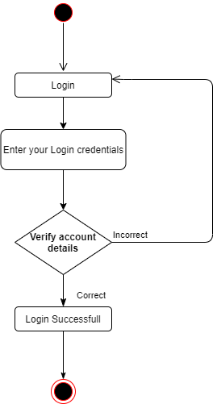

**Fig 3.5** Activity Diagram for Login

**3.2.3.3 Activity Diagram for NGO Management**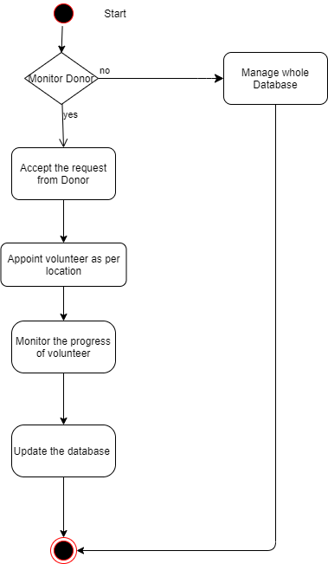

**Fig 3.6** Activity Diagram for NGO Management

**3.2.3.4 Activity Diagram for Donor**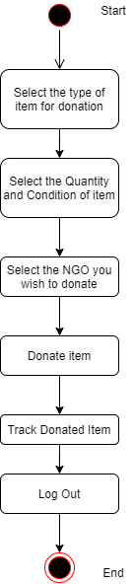

**Fig 3.7** Activity Diagram for Donor

**3.2.3.5 Activity Diagram for Volunteer**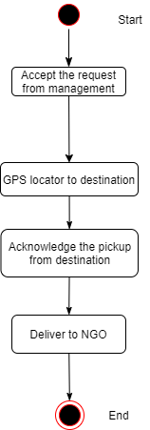

**Fig 3.8** Activity Diagram for Volunteer

**3.2.4 Sequence Diagram**

**3.2.4.1 Sequence Diagram for NGO Management**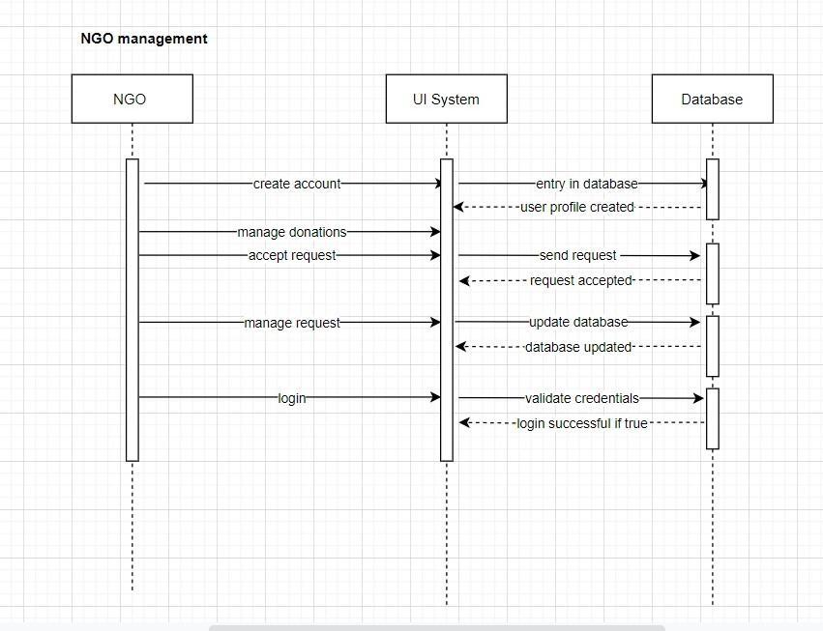

**Fig 3.9** Sequence Diagram for NGO Management

**3.2.4.2 Sequence Diagram for Donor**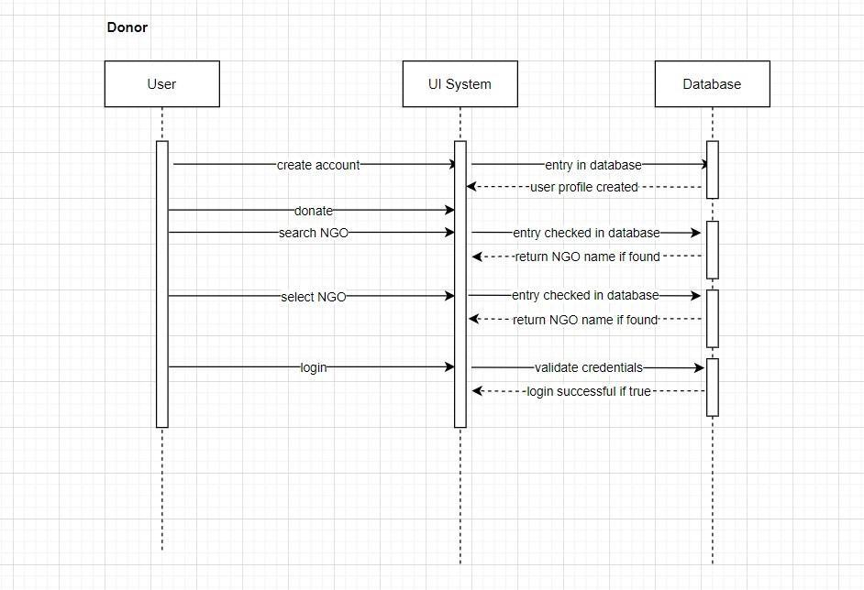

**Fig 3.10** Sequence Diagram for Donor

**3.2.4.3 Sequence Diagram for Volunteer**

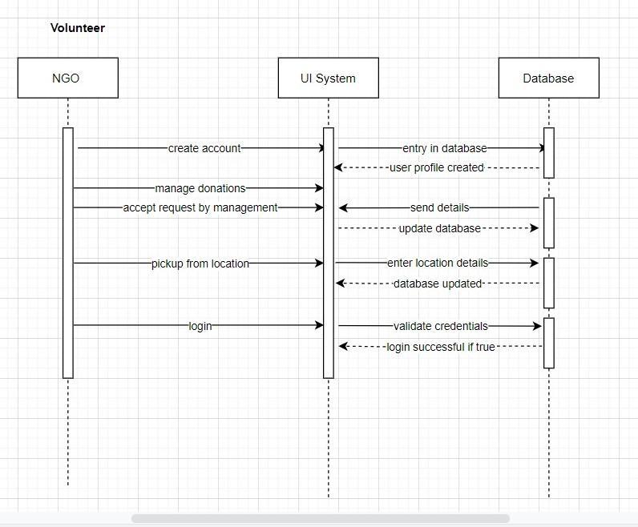

**Fig 3.11** Sequence Diagram for Volunteer

* 1. **Database Design**
     1. **E-R Diagram**

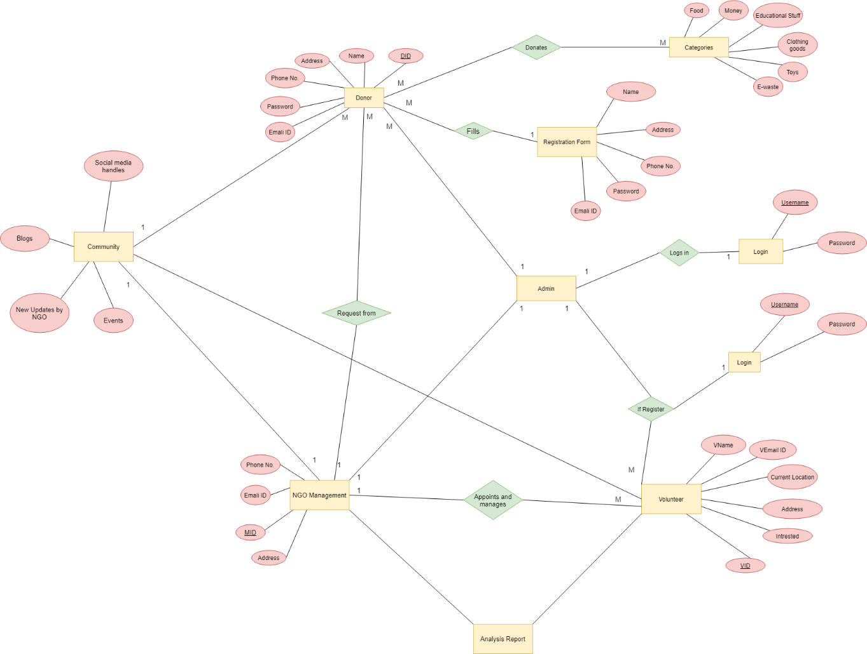

**Fig. 3.12** E-R Diagram

* + 1. **Data Dictionary**
       1. **Donor table**

| **Field Names** | **Data Type** | **Constraint** |
| --- | --- | --- |
| DID | Varchar2(50) | Primary Key |
| Name | Varchar2(25) | Not Null |
| Address | Varchar2(60) | Not Null |
| Phone No. | Numeric (20,0) | Not Null |
| Password | Varchar (50) | Not Null |
| Email ID | Varchar (50) | Not Null |

**Table 3.1** Donor Table

* + - 1. **Volunteer Table**

| **Field Names** | **Data Type** | **Constraint** |
| --- | --- | --- |
| VID | Varchar2(50) | Primary Key |
| VName | Varchar2(50) | Not Null |
| Address | Varchar2(60) | Not Null |
| Phone No. | Numeric (20,0) | Not Null |
| Password | Varchar (50) | Not Null |
| Email ID | Varchar (50) | Not Null |
| Current Location | Varchar (25) | Not Null |
| Drives No. | Varchar (30) | Not Null |

**Table 3.2** Volunteer table

* + - 1. **NGO management table**

| **Field Names** | **Data Type** | **Constraint** |
| --- | --- | --- |
| MID | Varchar2(50) | Primary Key |
| Name | Varchar2(25) | Not Null |
| Address | Varchar2(60) | Not Null |
| Phone No. | Numeric (20,0) | Not Null |
| Password | Varchar (50) | Not Null |
| Email ID | Varchar (50) | Not Null |
| Number of requests | Numeric (30) | Not Null |

**Table 3.3** NGO management table

**3.3.2.4 Registration details table**

| **Field Names** | **Data Type** | **Constraint** |
| --- | --- | --- |
| Name | Varchar2(25) | Not Null |
| Address | Varchar2(60) | Not Null |
| Phone No. | Numeric (20,0) | Not Null |
| Password | Varchar (50) | Not Null |
| Email ID | Varchar (50) | Not Null |

**Table 3.4** Registration Details Table

**3.3.2.5 Registered user table**

| **Field Names** | **Data Type** | **Constraint** |
| --- | --- | --- |
| User ID | Varchar2(25) | Primary key |
| Username | Varchar2(25) | Not Null |
| Password | Varchar2(60) | Not Null |

**Table 3.5** Registered user table

**3.3.2.6 Donated items table**

| **Field Names** | **Data Type** | **Constraint** |
| --- | --- | --- |
| Item number | Numeric | Primary key |
| Type | Varchar2(25) | Not Null |
| uantity | Numeric | Not Null |
| Delivery status | Boolean | Not null |
| Pickup location | Varchar2(25) | Not null |
| Delivery location | Varchar2(25) | Not null |

**Table 3.6** Donated items table

* 1. **Business model canvas**

**BUILDING BLOCKS OF BUSINESS MODEL CANVAS**

1. Customer Segments

2. Value proposition

3. Channels

4. Customers relationships

5. Revenue streams

6. Key resources

7. Key activities

8. Key partners

9. Cost structure

Key Partners

The main partners of this product will be the NGOs. NGO management will appoint volunteers to pickup from the location that is entered by the donors.

Key Activities

One of the main activities is collecting item from pickup location. Donors enter the pickup location which the NGO management sees and appoints a volunteer to pickup item from that location. Volunteers delivering the item can be tracked and their performance can be assessed as well.

Key Resources

Volunteers(manpower) are needed to deliver the item at its delivery location. Since everything else is in the digital form as an android application, an android device is needed to access it.

Value Propositions

The main value to be delivered to the customers will be an application that provides for hassle free donations to NGOs of their choice that they select and also a simple and convenient mechanism that aims at connecting NGOs and donors.

Customer Relationships

The product will help donors to donate items they wish to and they can see the status of their item and can have the satisfaction of donating to the needy via our application.

Channels

The main channel to reach to our application is the google play store where the android application shall be available for people to download. Social media handles of NGOs can also post about our application acting as a channel via which people can reach our app.

Customer Segments

The potential customers will be the donors and NGOs.

Cost Structure

Our application is free to download for users.

Revenue Streams

The application has no payment module and neither do we generate any revenue from it. It is merely an intermediary between NGOs and donors.

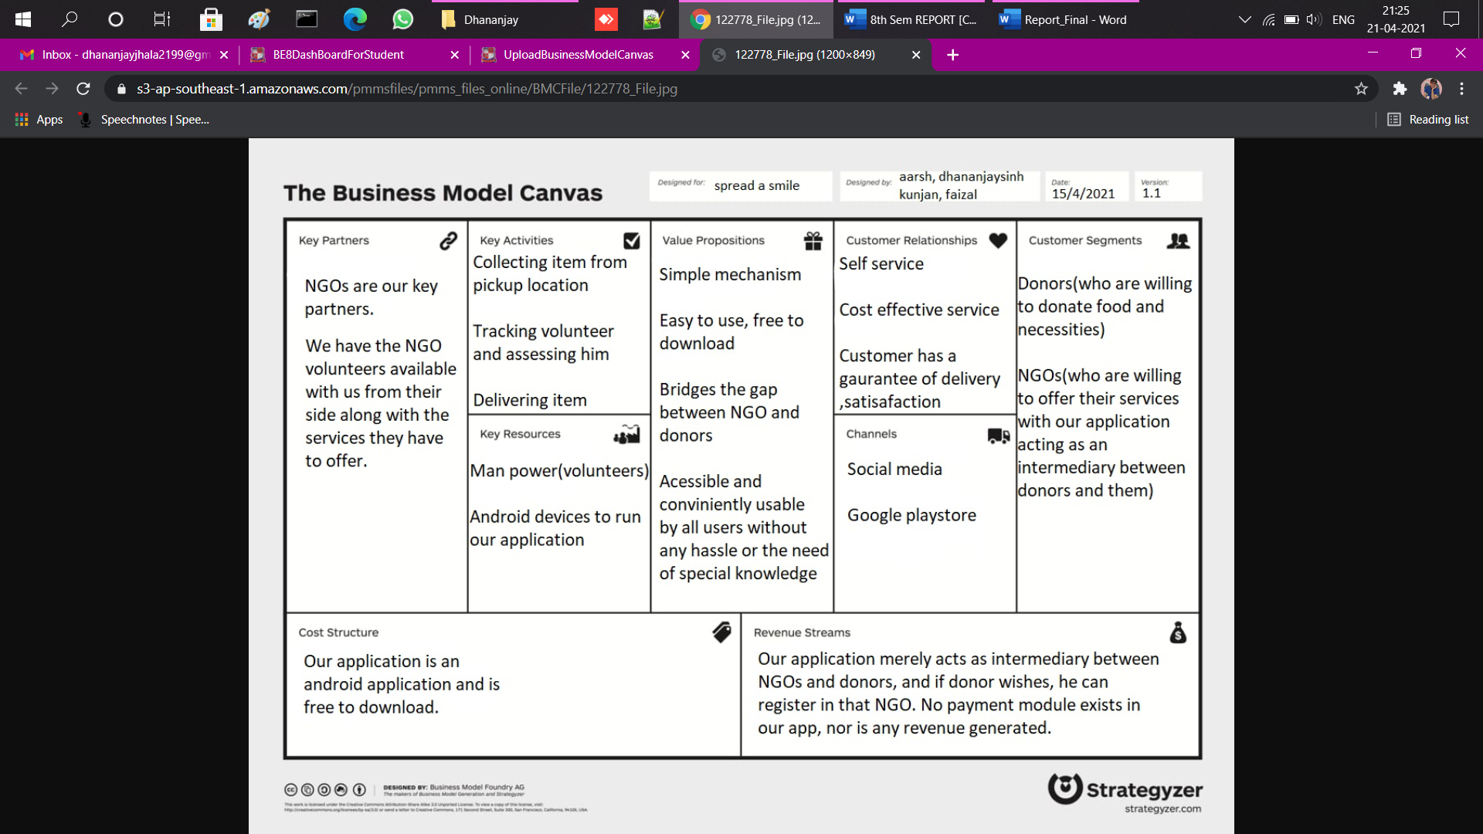

**Fig. 3.13 BMC Canvas**

**Chapter: 04**

**SYSTEM DESCRIPTION**

**4.1 Software Description:**

We have built our front end on **Android Studio**. Android Studio is the official integrated development environment (IDE) for Google's Android operating system, built on JetBrains' IntelliJ IDEA software and designed specifically for Android development. It is available for download on Windows, macOS and Linux based operating systems or as a subscription-based service in 2020. It is a replacement for the Eclipse Android Development Tools (E-ADT) as the primary IDE for native Android application development. Android Studio supports all the same programming languages of IntelliJ (and CLion) e.g. Java, C++, and more with extensions, such as Go; and Android Studio 3.0 or later supports Kotlin and "all Java 7 language features and a subset of Java 8 language features that vary by platform version." External projects backport some Java 9 features. While IntelliJ states that Android Studio supports all released Java versions, and Java 12, it's not clear to what level Android Studio supports Java versions up to Java 12 (the documentation mentions partial Java 8 support). At least some new language features up to Java 12 are usable in Android.

**Chapter: 05**

**SYSTEM IMPLEMENTATION**

**5.1.1 Coding Standards:**

**• A coding standard gives a uniform appearance to the codes written by different**

**engineers.**

**• It improves readability and maintainability of the codes and it reduces complexity also.**

**• It helps in codes reuse and helps to detect error easily.**

**• It promotes sound programming practices and increases efficiency of the programmers.**

**5.1.2 Total Module:**

**In our system, there are total four module in our website and every module**

**connected with each other.**

**Four modules are:**

**1. User: User of our app would mainly the donor. Donors can see the NGO and select NGO of their choice and then donate to NGO of their choice.**

**2. Admin: Admin will maintain database. Admin has all right to give as well as delete NGOs.**

**3. NGO management: NGO management will see the requests from the donor side and the appoint volunteers to pickup item from the location.**

**4. Volunteer: Volunteers will be appointed by the NGO management to pickup the item from the delivery location.**

**Chapter: 06**

**Conclusion and Future Scope**

**Reference:**

1) Software Engineering by Roger S. Pressman

2) Object Oriented Programming - Pearson Publication

**Links:**

1)https://developer.mozilla.org/en-US/docs/Learn/Tools_and_testing/Client-side_JavaScript_frameworks/React_getting_started

2)<https://www.javatpoint.com/nodejs-tutorial>

3) <https://sharethemeal.org/en/index.html>

**Conclusion:**

We would like to conclude that our project shall aim at helping the needy by connecting them with the donors by using the NGOs as an intermediary who shall do their job aided by the application that we shall provide them. Our application shall aim to mitigate issues like lack of awareness among donors, lack of transparency in the donation process and thus acts as a bridge between the people in need.

**Future scope:**

India is a developing nation and problems such as hunger and other issues are still prevalent to a large degree. We shall try to contribute out best by connecting the people in need with the providers and donors. We shall try and expand our application scope to other platforms such as IOS and also shall try to expand our reach and the amount of help we provide.

**Appendix A: Canvas**

* 1. **AEIOU Canvas**

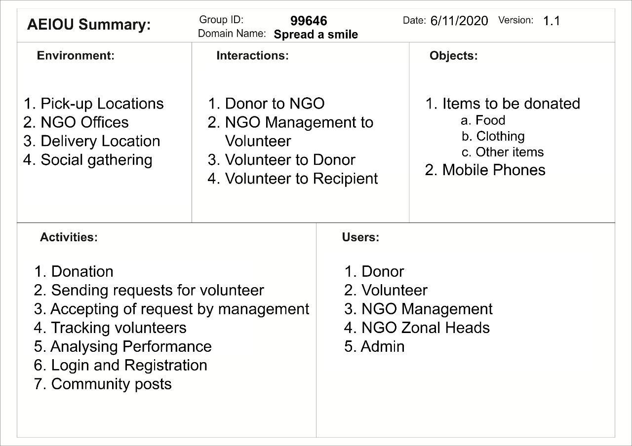

**Fig 5.1** AEIOU Canvas

* 1. **Empathy Canvas**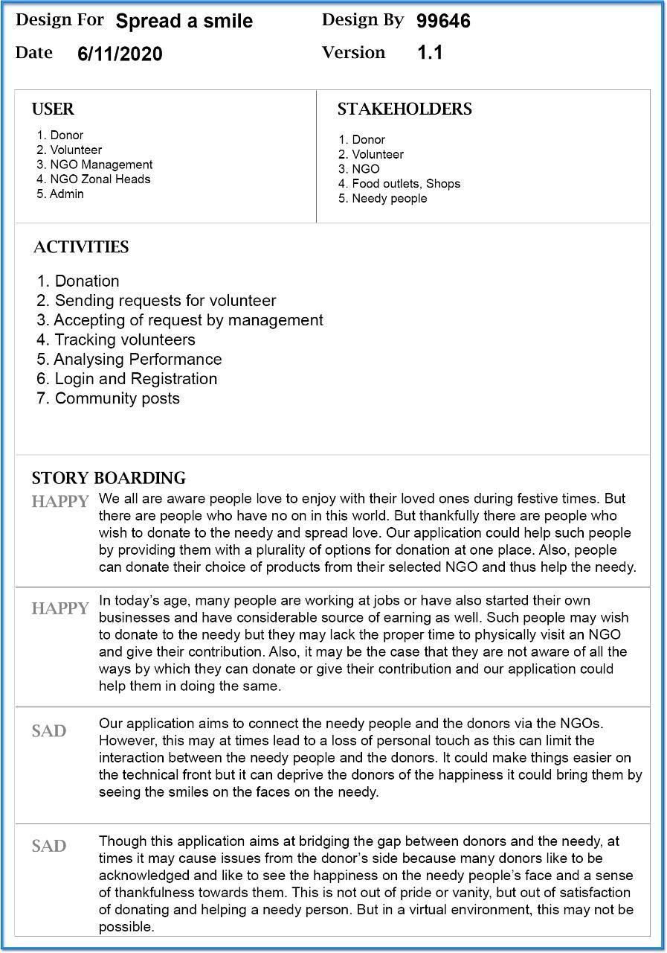

**Fig5.2** Empathy Canvas

* 1. **Ideation canvas**

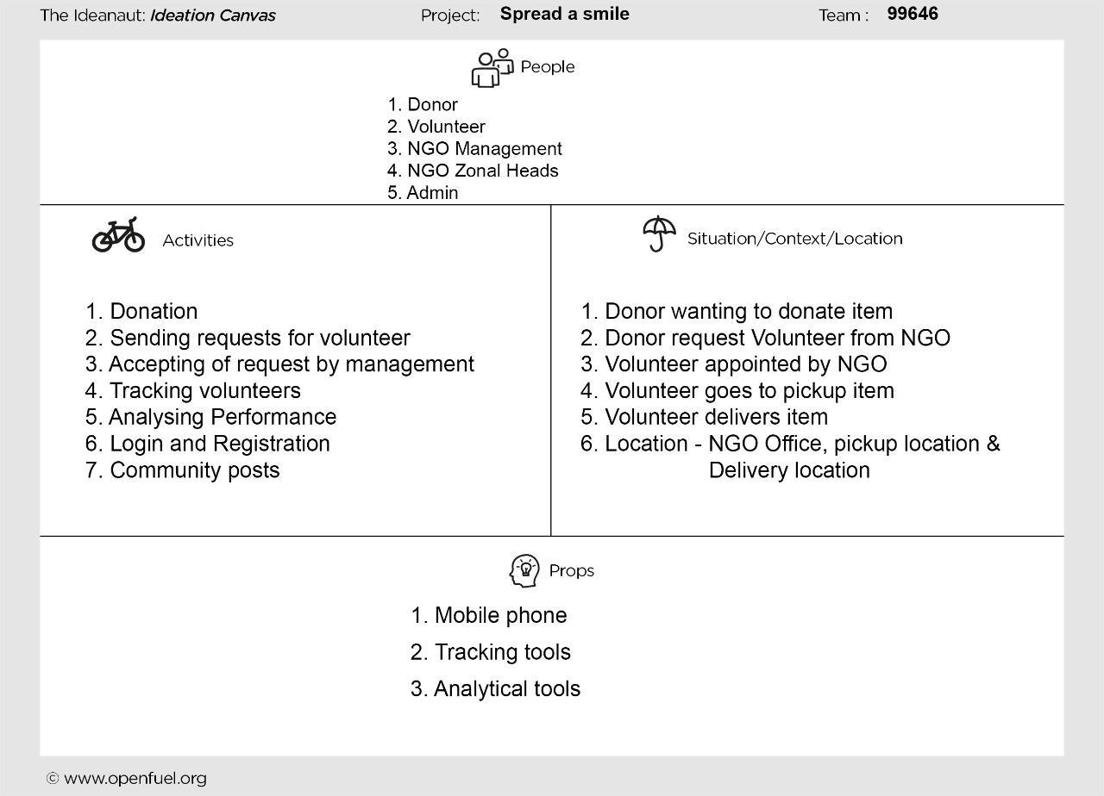

**Fig5.3** Ideation Canvas

* 1. **Product Development Canvas**

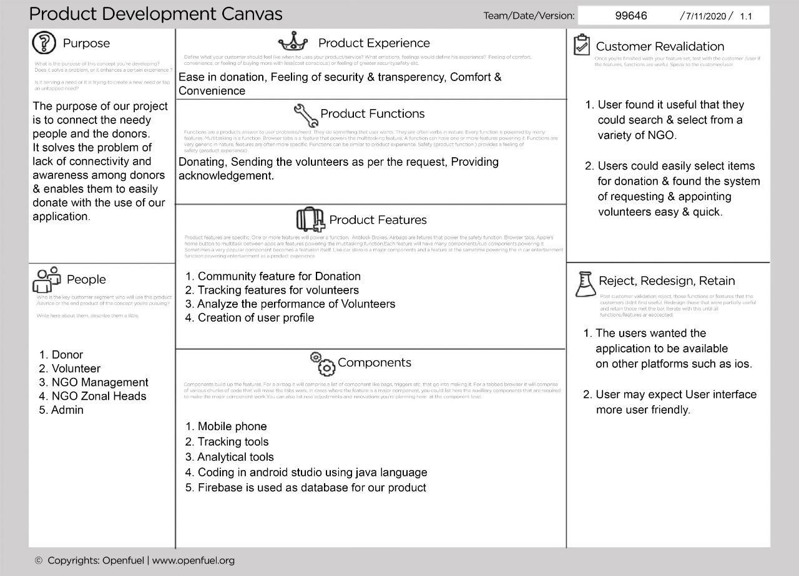

**Fig 5.4** Product Development canvas